**ALBANIA**

**Climate Resilience and Agriculture Development Project**

**Terms of Reference**

**Consulting Services**

*for*

**Design Review and Construction Supervision for modernization and pressurization of the Divjaka & Janjar – Mursi Irrigation schemes**

**Ref. No. AL-MARD-389921-CS-QCBS**

1. **BACKGROUND AND PROJECT OVERVIEW**

The Government of Albania (GoA) has received financing in the total amount of US$ 70 million equivalents from the World Bank (the Bank) towards the cost of the Climate Resilience and Agriculture Development Project (CRAD).

The Ministry of Agriculture and Rural Development (MoARD) is the implementing agency of the CRAD Project. MoARD intends to apply a portion of the proceeds of this Loan to Consultancy Services for Design Review and Construction Supervision for modernization and pressurization of the Divjaka & Janjar - Mursi Irrigation schemes, located in Lushnje and Konispol areas, respectively.

Although Albania is endowed with water resources and with an annual average rainfall of 1,485 mm, the fact that about 20 percent of the total amount falls during the summer period makes irrigation indispensable. An estimated 360,000 hectares have been equipped with irrigation facility, 280,000 hectares with drainage facility, and 130,000 hectares is marine flood protection, but in 2009 only 80,000 ha was irrigated (22 percent of the equipped area). About 626 agricultural reservoirs provide 0.56 billion m3 of water for irrigation purposes mainly during the hot and dry summer season. Irrigation is the country’s largest consumptive water user– and by far the least efficient.

The sector, which is regulated by the Ministry of Agriculture and Rural Development (MoARD), also consumes a considerable share of public resources which is required to operate, maintain, and upgrade the irrigation and drainage (I&D) infrastructure and secure the safety of the irrigation dams and flood protection systems.

The World Bank has been the main partner of the GOA in supporting the I&D sector and institutions since 1994. The Climate Resilience and Agriculture Development Project has the following objectives:(i) Promoting Climate Smart Agriculture and Access to Markets, (ii) Modernizing Selected Irrigation and Drainage Schemes for High-value Agriculture Production, and (iii) Enhancing Compliance with Food Safety and Quality Standards.

These Terms of Reference (TORs) relate to the modernization of Irrigation and Drainage schemes for High-value agriculture production. The selection of Divjaka & Mursi irrigation schemes was done under the previous World Bank (WB) Project "Water Resource and Irrigation Project (WRIP)" 2012-2017. The Feasibility Studies, Schematic Designs, and Detailed Designs for the modernization of the irrigation schemes were developed under the WRIP.

**A. Divjaka Pilot Irrigation Scheme**

***Description of the existing situation***

Divjaka irrigation scheme is part of the Lowland Zone in Lushnje District. The Divjaka irrigation scheme’s command area is 3,000 ha and is divided in to two sub-schemes of 1,500 ha each. The area is well connected with the transportation network, less than 10 km from the littoral highway connecting the Durres port at N and Valona port. The main city close to the area is Lushnje town. The western part of the scheme runs into the salty Karavasta lagoon. The northern boundary of the Divjaka Municipality is the Shkumbin Riverbed, which separates it from the Municipality of Rrogozhina, the southern boundary consists of the Seman River, in the east since it includes the Cermes plain area the boundary is smashed more or less in the center of the former Tërbufi Swamp and continues southward including also the plain area of Këmishaj-Gradishtë. The southern boundary coincides with the old Seman Riverbed, while the Adriatic Sea forms the western boundary of this Municipality.

**Water resources, availability for irrigation and water quality**

Currently the Interceptor main drain of Terbuf is the main source of water for the Divjake irrigagion scheme. The pressure head required is provided by Sulzotaj pumping station which takes water from Terbuf Interceptor Canal. Since the water for agriculture is taken from a main drain there are concerns about the quality of water and of a high nutrition rate in form of Nitrate or Ammonium in particular.

***Proposed Location of the Pilot Area***

The project location was defined during the preliminary design phase. The selection was a result of a consultation process with the affected parties, especially Municipality of Divjaka. The consultancy however developed wider possible location inside of the agricultural land of northern Divjaka. Such location was presented during a consultative meeting with representatives of the Divjaka municipality and MoARD, in accordance with pilot area of 500ha as indicated in the ToR. The Municipality has confirmed the selected location and communicated to the client which is in accordance with the ToR. This area is bordered to the north by the Tërbuf Emisari, in the west with the Karavasta Lagoon, in south with the urban area of Divjaka and in the east with Sulzotaj.

***Proposed pilot irrigation scheme layout***

Based on the water requirement and the existing infrastructure to be used, the consultant have divided the project area into 2 subzones (DMA). The subjected area will use some existing infrastructure constructed from the previous project under WRIP such as pumping station, main rising pipe (DU-1) and secondary irrigation (DU-6).

**Estimated civil work implementation time**

According to the original design it is estimated that rehabilitation works for Divjaka Pilot Scheme will be completed in a 8 (eight) month period.

***B. Janjar & Mursi Irrigation Scheme***

***Description of the existing situation***

Janjar & Mursi irrigation scheme is part of the Konispol District. The Konispol Municipality is located in the southernmost part of Albania, just one km from the Albanian-Greek border. The total command area has an extension of 5,400 ha, divided in two sub-schemes of 3,200ha covered by Janjar reservoir and 2,200ha by Mursi reservoir. The area is mostly known for growing high value crops, mandarin orange in particular.

**Water resources, availability for irrigation and water quality**

The main source of water for the proposed scheme are Janjar reservoir 15 million cum and Mursi 4 million cum. Janjar reservoir is mostly rain-fed whilst Mursi is filled by a supply canal taking water from Pavlla river. There are no concerns reported in relation to water quality for agriculture from both reservoirs.

***Proposed irrigation scheme layout***

The selection of Janjar/Mursi irrigation scheme was done under the previous WB financed WRIP 2012-2017. The Feasibility Study, Design and Detailed Designs for the modernization of the irrigation scheme were developed under the WRIP. The implementation of civil works was divided into two phases: (i) Janjar reservoir for 3,200ha and (ii) Mursi reservoir for 2,200ha. The Janjar & Mursi irrigation scheme is composed of: i) Janjar Reservoir including the dam and 22km of main irrigation canal of Janjar, Bufi Brach 14km supplied from Janjar Canal, Konispol Canal 11km supplied from Janjar Canal for 3,300ha; and ii) Mursi Reservoir including the dam and 33km of main canals V1,V2 and their secondary canals, Mursi feeder canal 5km and its secondary canals for 2200ha. The dam and primary/main canals and some secondary canals of Janjar reservoir were constructed under the WRIP and they are fully operational. The farmers of these areas are happy with the investments and are receiving benefits from the investment.

The situation in Mursi reservoir area is quite the opposite. The gravity irrigation canal network originally designed in late 80s is out of function and is old-fashioned since more and more farmers are shifting towards pressurized irrigation using small pumps extracting water from drainage canals. The purpose of the works is to modernize the irrigation to replace the open canal network with pipes and to erect a new pump station to provide sufficient head for pressurized irrigation techniques as drip, micro-sprinkler or sprinkler.

**Estimated civil work implementation time**

According to the original design it is estimated that rehabilitation works for Janjar/Mursi Irrigation Scheme will be completed in a 18 (eighteen) month period and the rehabilitation works for Divjaka Irrigation Scheme will be completed in a 8 (eight) months period.

1. **OBJECTIVES OF THE ASSIGNMENT**

The MoARD seeks the Consulting Services of a qualified consulting firm/consortium with the objective to assist MoARD with the Design and Construction Supervision of the Civil Works for the “*Modernization and Pressurization of Divjaka & Mursi - Janjar Irrigation schemes*” covering an area of 500ha and 2,200ha respectively, including Divjaka water source water quality monitoring & assessment, design review, changes, improvement, and/or additions to original drawings when necessary, monitoring, inspection, and reporting activities of standard supervision.

The Consultant will be responsible for providing qualified professional and supporting staff and all necessary services required for the efficient cost effective and timely execution of the Consultancy Services.

1. **SCOPE OF SERVICES AND TASKS (COMPONENTS)**

To achieve the objectives of this assignment, the Consulting Company in charge for Design Review and Civil Works Supervision shall generally perform the following tasks/activities to the satisfaction of the Client and standard engineering practices as outlined below. The Consultant shall provide full Supervisory services during the execution of the Civil Works, extended, also, from time to time during the Defects Liability Period (DLP), as necessary.

* Prepare monitoring and assessment report on Water Source Quality for Agriculture of Divjaka Pilot Irrigation Scheme.
* Because original detailed implementation drawings and BoQs were developed 5 yrs ago there is a need to review and update drawings and costs to reflect possible adaptations of technical solutions and cost estimate. The Consultant will update the original drawings and design new additional infrastructures if needed. The Consultant will assist the MoARD in preparation of revised Bill of Quantities (BoQs) part of Bidding Documents.
* The Consultant will carry out supervision of the civil works contract. The consultant’s team must be designed and fully specified in the Technical Proposal to provide for both overall management and supervision of the works contract. Details of the invitation/evaluation of proposals are given in the Request for Proposals
* This supervision service comprises working with the contractor to ensure an orderly start-up and timely execution of the works; a full array of quality assurance activities; certification of payments; co-ordination with stakeholders; contract administration; changes and improvement to the original designs for problems encountered; improvement of the design; development of variation orders as needed, including scoping, independent pricing, and negotiation; communication and facilitation of communication among all necessary parties and reporting monthly progress;
* The Consultant shall, through its supervision team and central support resources, assist the Client in all contract management tasks, including the preparation for, the execution of, and the taking over of any elements of the works
* It is envisaged that the assignment would be carried out according to the duration of the works for modernization and pressurization of Divjaka & Janjar - Mursi Irrigation schemes. The Consultant Company is also required to be available periodically during the 12 months Defects Liability Period (DLP)
* The invited Consultants should submit their staffing details for supervision of the Civil Works Contract as mentioned in the Request for Proposals.
  1. **DUTIES & RESPONSIBILITIES OF THE SUPERVISION CONSULTANT**

In assisting the Client for satisfactory completion of the construction of the Civil Works, the assignment is divided in 2 (two) phases: (i) Review and update the original detailed drawings and BoQs and assist the MoARD in the preparation of Bidding Documents for Civil Works, and (ii) Supervision of the Civil Works. The Consultant shall undertake but not limited to the following duties:

1. Phase 1 – Review and update the original detailed designs and conduct a water quality monitoring and assessment, including proposing remedial measures of the Divjaka irrigation scheme.

* During this phase, the consulting company will review and update the original detailed drawings and BoQs. The Consultant will also assist the MoARD in preparing Bidding Documents for the Civil Works.
* During this phase, the consulting company will conduct and deliver an agriculture water quality monitoring and assessment of the Divjaka Pilot Irrigation Scheme. The results of the assessment should meet the water quality requirements for agricultural irrigation under “Water Quality for Agriculture” FAO Irrigation and Drainage Paper 29, Rev.1 Reprinted 1994. In case the monitoring reveals that the water quality doesn’t meet required standards, the Consultant should formulate recommendations on how to address this issue.

The duration of this phase is 3 (three months)

1. Phase II - Supervision of civil works

* The Supervision Consultant will monitor the Works Contract and ensure that contractual clauses whether related to quality or quantities of work, are respected. It will make the necessary measurements and control the quality of works, and will co‑ordinate all engineering decisions, including changes, improvement, and/or additions to the original designs, if necessary, required for the proper implementation of the contract.

However, the Supervision Consultant will seek approval of the MoARD to:

1. issue any Variation Orders (VOs) with financial implications, including negotiation of the proposed new prices (if any), except in an emergency, as reasonably determined by the Supervision Consultant
2. issue variations in work quantities
3. sanction additional items, sums or costs
4. approve the subcontracting of any part of the works; and
5. approve any extensions of the time for completion.

* The Supervision Consultant will carry out the following tasks, consulting with the Client (MoARD) as appropriate:

1. design additional structures where needed and update the original engineering design (prepared by a separate consultant), prepare all necessary improvements, changes and/or additions to the original designs, if necessary
2. issue the orders to commence the works
3. administer the civil works contract, approve the materials and quality of the works in accordance with the contract specifications
4. approve the Contractor’s work programmes and progress schedule and if required suggest modifications
5. approve method statement and the sources of materialsand monitor the Contractors’ laboratory testing
6. Inspect and evaluate the contractors' establishment including in particular the facilities to ensure compliance with the terms and conditions of the Civil Work Contract
7. approve the Contractor’s working construction drawings including variations thereof, approve the setting-out of the works and give instructions to the contractor in this regard
8. prepare changes to original designs for problems encountered during construction and expeditiously issue supplementary drawings, if needed
9. Evaluate design changes and/or value engineering proposals against appropriate criteria, to ensure environmental, social and health and safety risks and impacts are given due consideration
10. ascertain and determine by measurement the value of the works in accordance with the Contract, site measurement of the works and preparation of the work progress instalments.
11. issue Interim Payment Certificates (IPCs) for monthly payments, as well as the Final IPC and certify completion of parts or the totality of the works. In order to avoid delays, prior to signing by all responsible persons, the IPCs shall be firstly submitted as drafts (electronically) for review. Once the adjustments (if any) were carried out, then the IPCs will be signed by all responsible persons and will be submitted for payment execution
12. order site testing and procedures, such as geometrical dimensions, soil density and water content, grout and concrete mix quality control, and commissioning procedures are specified in the contract.
13. Inspection and assessment of equipment such as electromechanical equipment’s, valves, gates, pipes to ensure that these items are manufactured off site. The inspections can be handled either by the Consultant or by an accredited inspection agency on his behalf. Further inspections take place on arrival at site to be sure that any eventual damage in transit is rectified as soon as possible.
14. supervise material testing in the Contractor’ site laboratory and in-situ.
15. have the possibility of carrying out independent tests, in situ or lab, for checking soil properties, construction materials, concrete structure strength, contraction appurtenances and equipment etc.
16. ensure that all site activities follow the requirements of the MoARD in all matters related to the Environmental and Social Management Plan (ESMP) and Maintenance Programme as specified in the works contract, avoiding potential environmental impacts
17. inform and advise the MoARD on all matters related to the execution of the works contract including processing of the Contractor’s claims and submit if necessary confidential reports on the claims
18. prepare the “*As-built*” drawings throughout the duration of the Works Contract and at the end of the contract, two hard copies have to be furnished to MoARD and in addition one copy will also be submitted on CDs
19. Give all necessary instructions to the Contractor, providing that the Supervision Company shall not, without prior approval of the Client, give any instructions which, in the opinion of the Engineer are likely to increase the contract amounts or change the conditions of contract
20. In addition, Monthly Progress Meetings will be held regularly with Contractor, recommended in the site. During these meetings, formal minutes will be taken by the Supervision Consultant and distributed to the MoARD and Contractor
21. Carry out the necessary inspections, shortly before the end of the construction period and determine the remaining works to be completed
22. During the Defects Liability Period, the Consultant will carry out 4 (four) inspections and prepare the brief Inspection Reports on any issues or defects identified/repaired by the contractor.

* The Project Manager/Team Leader and the resident staff are under overall management of the Supervision Consultant (the Engineer) and shall carry out such duties and exercise authority as may be delegated to them by the Engineer. The main responsibilities of the Project Manager/Team Leader and Supervision Team are to:

1. inspect the performance of works in compliance with specifications; order, supervise or perform tests on materials; and approve or disapprove the contractor’s plant and equipment
2. check systematically the progress of the work, examine and attend the measurement of any work that is about to be covered, and order, if required, uncovering of unsatisfactory works and its satisfactory reconstruction
3. check Contractor’s invoices, claims and other statements with respect to arithmetical errors and compliance with the contract
4. supervise the Contractor in all matters concerning safety and care of the works, and direct operations in case of an emergency situation affecting the safety of life, of the works, or of adjoining property
5. verify and, if necessary, arrange correction of the Operating and Maintenance manuals supplied by the Contractor; and
6. carry out such duties, as may be delegated in writing from the Supervision Consultant, under the terms of the Contract.

When the works are satisfactorily completed, the Supervisor in collaboration with Civil Works contractor will prepare all completed (Final) documentations (6 copies) of the executed works and will ensure that contract files are kept with all applicable documents and that their copies are shared with the Client and respective Municipalities and Fieri Irrigation & Drainage Enterprise. The completed documentations should be submitted to the Client before taking-over of the investments.

The Supervision services shall be extended periodically during the Defects Liability Period (12 months), as necessary. The Supervision Company shall inspect the completed works within the term covering his contract, prepare lists of deficiencies (if any), and carry out supervision of the remedial works, and issue the Defects Liability Certificates/Final Taking-over Certificates after the rectification of notified defects by the Contractor.

The duration of the civil work contract will be 18 (eighteen) months, including 8 (eight) months after civil works contract signed for civil works for Divjaka scheme and 18 (eighteen) months after civil works contract signed for civil works for Mursi scheme.

1. **TEAM COMPOSITION & QUALIFICATION REQUIREMENTS OF THE EXPERTS**

The Design & Supervisory Services will be provided by a Consultant Company or a Joint Venture.

The interested Consultants should comply with the following requirements:

* + - 1. Have Extensive experience in Design & Construction Supervision and quality assurance the Consultant should have at least 10 years of experience, in the Design and Supervision of the Irrigation systems projects, reservoir dam included, in water supply & sewerage systems.
      2. Be familiar with the World Bank Safeguard policies, as well as other related guidelines and procedures.
      3. Previous experience with the World Bank projects will be an advantage.

The applicants will be assessed in order to determine a shortlist comprising the most qualified firms. The criteria to be used for shortlisting will be the following:

* Core business and years in business – 30 points
* Past experience in similar assignments – 60 points
* Availability of qualified staff among the firm to perform the assignment – 10 points

The CVs of Key experts will not be evaluated during the shortlisting process. The CVs of key experts will be evaluated after the issuance of the Request for Proposals to the shortlisted consultants. The evaluation shall be carried out in accordance with the evaluation criteria specified and detailed in the Request for Proposals.

It is anticipated that the Consultant would establish a strong Core Team (about 73.5 person/months for both phases) comprising of 6 (six) key-experts professionally qualified and appropriately experienced Engineers, with an Expert as the Project Manager/Team Leader (TL) and a full time Engineer as the Deputy Team Leader. Two experienced Hydraulic/Irrigation/Civil Engineers, a Geotechnical Specialist and an Environmental, Social, Health and Safety (ESHS) Expert will be part of the Core Team. Additional technical staff should be allocated as non-key staff to the supervision team of number, qualification and experience adequate to ensure proper quality control and measurement of Work Contract.

It is not necessary for the Team Leader to stay the whole duration of the contract in Albania, since a Deputy Team Leader (DTL) who is based in Albania shall be appointed on a full-time basis.

*The Supervision’s Consultant should provide the following* ***key professional staff*** *and their minimum qualifications:*

* **Project Manager (PM)/Team Leader (TL)**: Civil Engineer, preferably with a degree in hydraulics, with a minimum of 15 (fifteen) years’ experience in Design and the Contract Management or Supervision of Irrigation systems works. TLshould demonstrate that he/she has management experience and has successfully participated in at least 1 (one) Supervision contract as TL. He/she would have an overall supervisory role and be responsible for reviewing all the hydraulic designs before executing the Civil Works and prepare all necessary improvements, changes and/or additions to the original designs, if necessary, as well as the supervision of the contract. The Team Leader shall have the responsibilities for the performance of all tasks entrusted to the Consultant Company, by ensuring the collaborative teamwork and check that services are carried out in compliance with the ToRs.
* **Deputy Project Manager (DPM)/Deputy Team Leader (DTL)** on a full-time basis: Hydraulic/Civil Engineer, with a minimum 15 (fifteen) years’ experience on Design and Supervision or Irrigation/Agricultural dam system works. DPM/DTL should demonstrate that he/she has successfully participated in at least 2 (two) supervision contract in relevant areas. He/she would assist the Project Manager/TL for supervising the contract.
* **2 (Two) Site Resident Engineers** on a full-time basis: Hydraulic/Civil Engineer, with a minimum15 (fifteen) years’ experience in Supervision, preferable in agricultural pressurised system works. He/she will be responsible for daily supervision of rehabilitation works.
* **1 (One) Geotechnical Specialist/Engineer** on a part time basis: with a minimum of 15 (fifteen) years’ experience in earth filling, foundations and slope stabilisation. Experience in earth dam stability works will be desirable.
* **1 (One) Environmental, Social, Health and Safety (ESHS) Expert** on part-time basis. The ESHS Expert shall have the appropriate level of academic and professional qualifications and experience to recognize and to deliver good international industry practice with respect to ESHS. The person suitable for this position should be an Environmental Engineer/Scientist with a minimum of 7 (seven) years’ experience in implementation of Environment and Social Management Plans (ESMPs) in accordance with national/international practices.

The ESHS Expert should ensure the Contractor’s ESHS performance is in accordance with good international industry practice and delivers the Contractor’s ESHS obligations. This includes, but is not limited to:

* Review and approve the Contractor’s ESMP (C-ESMP), including all updates and revisions (not less than once every 6 monthly)
* Review and approve ESHS provisions of method statements plans, proposals, schedules, and all relevant Contractor’s documents
* Review and advise the relevant person (of the Engineer) on the ESHS risks and impacts of any design change proposals and the implications for compliance with ESMP, consent/permits and other relevant project requirements
* Undertake audits, supervisions and/or inspections of the site where the Contractor is undertaking activities related to the Works, to verify the Contractor’s compliance with ESHS requirements, with and without contractor and/or client relevant representatives, as necessary, but not less than once per month
* Undertake audits and inspections of Contractor’s accident logs, community liaison records, monitoring findings and other ESHS related documentation, as necessary, to confirm the Contractor’s compliance with ESHS requirements
* Agree remedial action/s and their timeframe for implementation in the event of a noncompliance with the Contractor’s ESHS obligations
* Attend meetings including site meetings, progress meetings to discuss and agree appropriate actions to ensure compliance with ESHS obligations
* Check that the Contractor’s actual reporting (content and timeliness) is in accordance with the Contractor’s contractual obligations
* Review and critique, in a timely manner, the Contractor’s ESHS documentation (including regular reports and incident reports) submitted to the Resident Engineer or named Key Expert with overall responsibility for the Engineer and to provide advice to ensure the accuracy and efficacy of the documentation
* Undertake liaison, from time to time and as necessary, with project stakeholders to identify and discuss any actual or potential ESHS issues, and report to Resident Engineer or named Key Expert with overall responsibility for the Engineer
* Prepare a brief Monthly Reports, part of the Monthly Progress Report of the Supervision Consultant that describes the work that the ESHS Expert has undertaken, the issues (including any Contractor’s ESHS noncompliance) identified, and the actions taken to address the issues

Due to the nature of the assignment and to ensure proper quality control and measurement of Work Contract as requiredin the ToRs, *the key staff would be supplemented by following additional* ***non-key staff*** with appropriate professional qualifications, for which they are nominated:

* **1 (One) Electro-mechanical Engineer** on a part time basis: with at least 10 (ten) years of experience in Irrigation Pumping Stations, mechanical parts etc.
* **1 (One) Agriculture Water Quality Specialist** on a part time basis: with at least 10 (ten) years of experience in assessment of water quality for agriculture
* **2 (Two) Survey Technicians**, on a full-time basis: with at least 15 (fifteen) years of experience on Topographic works. They will be responsible for in-situ Topographic Surveys

**6. REPORTING REQUIREMENTS AND TIME SCHEDULE FOR DELIVERABLES**

During carrying out of the services under this Consultancy Services, the Consultant will prepare and deliver the reports, in the format and content acceptable to the Client.

The importance of detailed and timely reporting cannot be overemphasised. Set out below are the reports and documents that must be produced, frequency, submission deadline and an outline of their content. These will be dynamic documents subject to amendment to effect improvements or accommodate the needs of the MoARD and its clients and the IBRD.

The Consultant shall furnish to the MoARD the following reports and documents in English language 3 (three) copies and in Albanian 4 (four) copies, both, in hardcopy, as well as, by full electronic copy (2 CD/DVD), in word and PDF format, incorporated all comments provided. It is required that all reports should contain photos from different stage of project implementation, as necessary.

1. **Inception Report**: with details of how the Consultant will implement the project and setting out all measures for the mobilization of the key experts and supervision staff, non-key expert included any issues encountered during the mobilization of the Supervision Team and Contractor of the Civil Works with the recommendations for further procedures. The Inception Report should contain, as well, the review of the Contractor's Work Program and construction methods.

Delivery 1: **2(two) weeks after Contract Signing**.

1. **Water Quality Monitoring & Assessment Report and Design Review Report and assist in preparation of Bidding Documents for Civil Works**: will provide all findings from the review of the original engineering design. Whether design improvements have been recommended, the Consultant should accordingly prepare and submit all necessary improvements, changes and/or additions to the original designs/drawings.

Delivery 2: **3 (three) months after Contract Signing**.

Delivery 1 and 2 are part of the design review phase and assistance in preparation of the tender documents.

1. **Monthly Progress Reports for construction supervision**: (covering all Irrigation works under the Works Contract) commencing at the end of the first complete month following the date of Contract for Civil Works signed between the Contractor and the Employer for construction of works, and ending at the end of the month in which the issue of the provisional completion certificate (i.e., the starting date of the one-year Defects Liability Period – DLP) takes place.

Delivery 3: **1** **(one) week after last day of each month**.

Delivery 3 are part of the supervision phase of the civil works.

The Monthly Progress Reports should be based on the physical and financial progress, as well as dealing with contractual and technical matters. They will make use of graphics and include statements covering (but not limited to) the following:

* Physical progress related to programme and time
* Explanations for variances to the above
* Expenditure related to cash flow forecast and budget
* Explanations for variances to the above
* Claims or disputes
* Human resources, mechanical equipment and materials
* Testing and quality control
* Local issues/Stakeholder issues
* A revised Cash Flow forecast

In addition, the Monthly Progress Report shall contain the brief Monthly Reports prepare by the ESHS Expert (part of her/his tasks), as well as any Environmental issues (including monitoring of ESMP).

The Monthly Progress Reports shall indicate any issues that may require the attention of the Client, in particular, if there are any changes on volumes and/or items on BoQs affecting the total value of the contract.

Whenever any unforeseen issues arise, which required the prompt Client’s mediation, to avoid adverse impacts or further delays, which may risk the works or result in additional cost, the Consultant shall immediately inform the Client through the Intermediate Report or, at least, advance notification by e-mail, as necessary. In addition, the Incident Reports would be produced by the Consultant if any need to inform the contracting authority on a particular issue or if the Consultant is asked to analyse a particular matter.

Since the Services consist of the supervision of Civil Works, taking any action under a civil works contract designating the Consultant as “Engineer”, for which action, pursuant to such civil works contract, the written approval of the Client as “Employer” is required.

1. **Draft Completion Report:** The Draft Completion Report will provide an overview of the project and to what extend the project objectives have successfully been achieved and the contract has been satisfactory implemented. The Draft Completion Report should also contain summary of the preparation of final documentation and the Provisional Taking-over process, including the issue of Provisional Taking-over Certificate.

Delivery 4: **2 (two) weeks prior to completion of the contract period**.

The report will include, but not be limited to, the following inputs:

* Overall review of the project
* Physical progress related to the original programme
* Explanations for variances to the above
* Expenditure related to original budgets
* Explanations for variances to the above
* Describe Consultant’s experiences in operating and monitoring the work of the contractor. This section of the report shall be fully detailed, examining manpower, material and administrative requirements and any other matters that may assist MoARD
* Report on success or otherwise of ESMP and monitoring of same

1. **Completion Report:** The Completion Report will be based on the Draft Completion Report but will incorporate any comments/suggestions provided by the reviewing parties (IBRD, MoARD, DSRP).

Delivery 5: **2 (two) weeks after completion of the contract period or after comments on the Draft Completion Report are provided by the MoARD, whichever comes later.**

1. **“As-built” Drawings:**

English 2 Copies and Albanian 2 Copies in printed format and 1 copy on CD

Delivery 6: **2 (two) weeks after “Taking-over” Certificate is issued**.

1. **Defects Liability Period Inspection Reports:** Describe any issues identified during the inspections.

Delivery 7: **1 (one) week after each three-monthly inspection of the Works Contract during the Defects Liability Period**.

1. **Final Report:** The Final Report will be based on the previously produced Completion Report but will incorporate any issues raised during the DLP and summarized the inspections and the remedial works carried out by the Contractor (if any). In addition, the Final Report shall contain any issues concerning the ESHS. This report should also describe the Final Taking-over process, including the issue of Final Taking-over Certificate.

Delivery 8: **2 (two) weeks after completion of the Defects Liability Period**.

**7. CLIENT’S INPUT AND COUNTERPART PERSONNEL**

### Data to be provided by the MoARD will include:

### Full Documentation of Civil Works’ Contract, which will be supervised (Designs, Reports, BoQs), annexes included. To facilitate the design review, the design documents will also be provided when RFP (Request for Proposal) will be issued to the shortlisted consultants.

### Environmental and Social Management Plans (ESMPs) for this specific area

1. Local services will not be provided
2. The Environmental Management Expert, part of PMT will liaise with the ESHS concerning the environmental, social and health and safety
3. Additional personnel will not be provided
4. Facilities to be provided: None

**8. INSTITUTIONAL ARRANGEMENTS**

* + - 1. The Project Manager/Team Leader of the Design and Supervision Team will report to the PMT of MoARD but has wide functional responsibilities to the MoARD.
      2. He/she will liaise with the respective MoARD’ directorates, Local Governments and other relevant institutions and stakeholders, as required.

**9. PERIOD AND TIME SCHEDULE OF THE SUPERVISION CONTRACT**

It is envisaged that the implementation period for the required design review services will be 3 (three) months for Phase 1 “Review and update the original detailed designs and conduct a water quality monitoring and assessment” after contract signing and 18 (eighteen) months for Phase II “Supervision of civil works”, after the civil works contract signed, according to the duration of the works for rehabilitation/modernization of Divjaka & Janjar-Mursi Irrigation schemes. The Consultant Company is also required to be available periodically during the Defects Liability Period (DLP), which will be 12 months after completion of the implementation of Civil Works. The Consultant Company should propose a clear schedule with critical milestones for all components as part of the Inception Report and make all possible efforts for timely works completion.

The Employer may require the Contractor to suspend I&D rehabilitation works due to irrigation season (May – September) or irrigation needs. In this case the Supervision Contract shall be suspended for the same amount of time and this time period shall not be considered for remuneration or reimbursable.

1. **SELECTION**

The consulting firm will be selected under the provisions of the World Bank Procurement Regulations for IPF Borrowers “Procurement in Investment Project Financing Goods, Works, Non-Consulting and Consulting Services (July 2016, Revised November 2017, August 2018, November 2020), based on the method of Quality and Cost Based Selection Method, Lump – Sum Contract for the Design Phase and Time – Based Contract for Supervision Phase. The Bank requires that firms or individuals involved in Bank IPF procurement shall not have conflict of interest.

**ANEX A**

**PROPOSED REHABILITATION WORKS**

**A. BRIEF DESCRIPTION OF DIVJAKA PILOT IRRIGATION SCHEME**

***1. Project area location and history***

***1. Project area location and history***

**The district of Lushnje** is the most important agriculture area of the country. It is part of Fier region. Lushnjë district is known as the main supplier of food for the Albanian population. The whole Lushnje is cropped along intensive practices and hosts the largest number of greenhouses. Divjaka is one of most intensive farming areas of this district. This area is well known for the intensive cultivation of vegetables. Divjaka grows 800 ha of vegetables in open field, usually with 3 crops rotated per year. Different irrigation systems are used, from furrow to sprinkler to drip irrigation, depending on the technology level of the farmer: thus, the vegetables irrigation efficiency is highly variable.

Throughout the year Divjaka produces open field vegetables such as carrots, cabbage, cauliflower and broccoli. In addition, minor areas are cropped with other vegetables such as beet, beetroot, etc. The micro-climate conditions and soil structure are very suitable to produce open field crops. The AAC experts estimate that the average income from vegetables production in Lushnje is 1-1.3 million ALL/ha.

The area of Divjaka is well-known for the cultivation of vegetables. Since the water available for irrigation and the cropping systems are changing, in some areas of Divjaka and Murriz Thane, the vegetables and cereals have lost of importance in the local economy. As a result, these farmers cultivate limited areas with vegetable and cereals (especially maize) and use low levels of inputs (improved seed, fertilizers, etc) and harvest products of low quality. The yield in these areas is much lower than in the rest of the district. The challenge is to improve irrigation to raise the maize yield from 6 ton/ha to 10 or 11 ton/ha with peaks of 13-14 ton/ha. Vegetables could reach a yield of 35 ton/ha with peaks of 60 Ton/ha. The present historically high trends in the international price of food encourage farmers to improve the cropping of with maize and vegetable crops.

**DIVJAKA IRRIGATION SCHEME**

Divjaka irrigation scheme is part of the Lowland Zone in Lushnje District. The Divjaka irrigation scheme gas a command area of 3,000 ha, divided in two sub-schemes of 1,500 ha each. The area is well connected with the transportation network, less than 10 km from the littoral highway connecting the Durres port at N and Valona port. The main city close to the area is Lushnje town. The western part of the scheme runs into the salty Karavasta lagoon.

The drainage system was built in the years 1960-1964, while the irrigation network later in the ‘70s, starting with Divjaka, Xengu 1, Xengu 2 and Miza reservoirs to feed the Divjaka irrigation scheme. These reservoirs, without a direct catchment area, were supplied by pumping station suctioning water from the drainage network. the Divjaka and Biscukas pump stations were installed in 1988 and 1989. In the ‘80s the PS of Puleria and the anti-salt barrage, downstream of it, were constructed, the latter trying to arrest the intrusion of the sea water into the freshwater aquifer.

Since the construction, the scheme was managed by state-own agricultural cooperatives, and it has maintained this status until 1992 when the cooperatives were disbanded, and the land distributed to farmers. From that time the I&D systems started to suffer low O&M activities, when the competence where shared between DBs and WUOs and the public investments started decreasing as well. Neither the experimented IMT undertaken by Albanian Government could stop the decay of the system.

***2. WATER RESOURCES, AVAILABILITY FOR IRRIGATION AND WATER QUALITY***

Currently the Terbuf interceptor drain is the main source of water for the Divjake irrigation scheme. It drains an area of c.a. 8,500 ha. Along Emisari Terbuf canal are located two pumping stations (PSs)- Bishcukas and Divjake PSs supplying a discharge of 1.5 m³/s for irrigation purpose. The main drain of irrigation area also receives the flow from the high-level contour canal which receives the run-off from the hilly area. This high-level contour canal confluence in the drain is located downstream Bishcukas pumping station. The main portion of this area is located south of the drainage canal. It comprises an irrigable area of about 2,650 ha, of which 400 ha have salinity problems. The irrigable area is partly served by Divjaka reservoir, which has a storage capacity of 4.5 million m³. This reservoir has a small direct catchment (2.2 km²), not enough to fill the reservoir. During wintertime an additional 0.5 m³/s discharge is supplied to the reservoir from Divjaka booster pump station located downstream in Divjaka dam. Another part of the area was irrigated by other three small reservoirs (Xengu 1, Xengu 2 and Miza) which have a storage capacity of about 0.75 million m³ only. Due to the small catchment areas limited run-off can fill them occasionally.

* + - 1. **IRRIGATION INFRASTRUCTURE AND IRRIGATION SYSTEM**

The Divjaka irrigation scheme with a command area of 3,000 ha, is mainly composed of two sub-schemes named South and North Divjaka each with a command area of 1,500 ha. **South** **Divjaka scheme** is mostly supplied by Divjaka, Xengu 1, Xengu 2 and Miza reservoirs. Divjaka’ s reservoir is the largest one with a capacity of 4.5 Mm³ (Coord. N 40° 59' 43.0" E 19° 33' 08.4""). The reservoirs of Xengu 1, Xengu 2 and Miza had a designed capacity of 0.18, 0.12 and 0.45 million m³, respectively, but at the present-day Miza is no more available. **North Divjaka sub-scheme** is fed by the Divjaka reservoir and by two pumping stations: Sulzotaj and Divjaka booster. The two pump stations were recently built as part of the investment of the project.

* + - 1. **CONDITION OF IRRIGATION NETWORK**

Both (North Divjaka and South Divjaka) sub-schemes were part of the investments under the WRIP project. The North Divjaka sub-scheme is designed as a pressurized irrigation scheme whilst the South Divjaka sub-scheme is a combination of pressurized and gravity. The project has invested in building 2 pumping stations, main pipelines and some sub-mains.

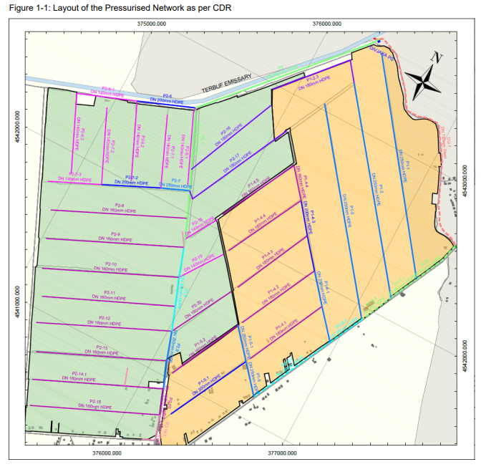

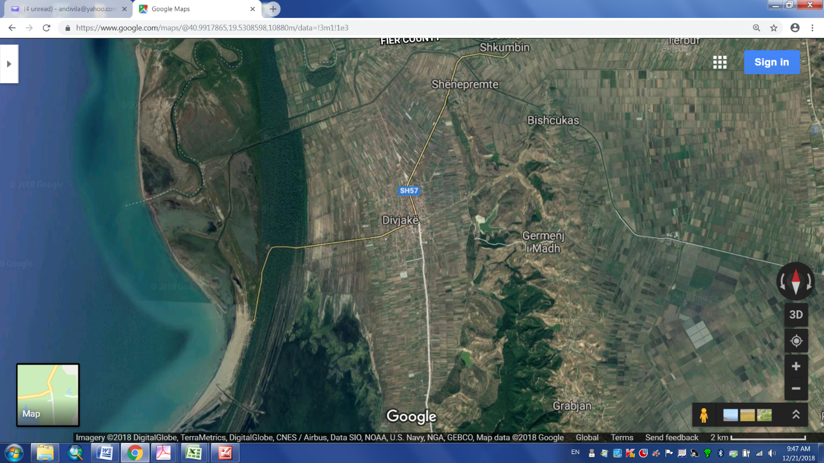

* + - 1. **WATER SOURCE**

The main source of water for irrigation purposes is the Divjaka reservoir with a designed capacity 4.5Mm3 but from siltation it is estimated at present value of around 3.5 Mm3

But referring exclusively to the selected irrigation Pilot scheme in North Divjaka, the main source of the water is Emisari of Terbuf supplying a discharge of 1.5 m³/s for irrigation purposes. The irrigation Pilot scheme is fed by Divjaka P.S (3 +1 Pumps Q=250l/s) and contributes to fill the reservoir by means of booster pumps (2 +1 Pumps Q=125l/s).

* + - 1. **RELATED INFRASTRUCTURE TO THE PILOT AREA**

At the proposed project area, the following existing infrastructure shall be used:

1. Pumping Station

2. Rising Main DU-1

3. Primary Pressure pipe DU-6

Design Concept

In accordance with the ToRs, it is required to design a fully pressurized piped irrigation system.

A pressurized piped irrigation system is a network installation consisting of pipes, fittings and other devices properly designed and installed to supply water under pressure from the source of the water to the irrigable area. The pressure of the system in accordance with ToRs it is guided to maintain a pressure between 2.0 – 3.0 bars. Therefore, the planned system would be **“low pressure systems”.** The calculations show that the existing system mostly fits with the required conditions for the development of the pressurized network. Main parameters are presented on the below table:

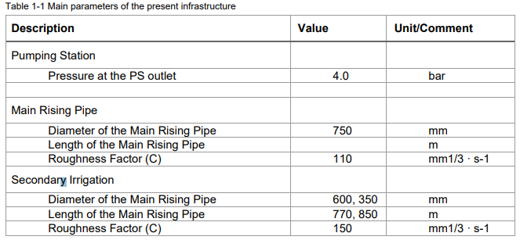

Taking into consideration that the water source, Pumping Station and the rising pipe already exist, the consultant in the conceptual design have made the following assumptions:

• The new Pilot Irrigation scheme of 500 ha must be supplied by main Divjaka P.S

• The Pilot Irrigation scheme of 500 ha shall be divided in two zones (DMA), respectively 205 ha and 250 ha

• The first Division has an intensive area of 205 ha part of existing system WRIP project supplied by DU-6

• The second Division of 250 ha directed in Westward of North scheme is a new developed area supplied by an independent direct line from Divjaka P.S

• The new system in any case should not change the original concept in terms of flow and pressure of the existing system.

Based on the planning bases and design criteria presented in the conceptual design the consultant has developed the hydraulic model using the computer software WaterCad. The new system comprises a branched pressurized network with pipes in HDPE from OD110mm – OD550mm (See Table 1-2). Distribution of the water demand is done into hydrants considering exactly the supply area of each hydrant.

The first Clément model is used for the Calculation of the capacity for on demand operation. Specific continuous discharge of 0.7 l/s*ha for 24hr/day is accepted.

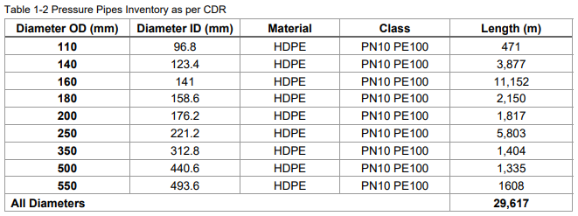

Selection of the pipe diameters was done to meet the design criteria and to insure balance of head losses and medium velocity.



The above-mentioned layout of piping and accessories was presented in the consultation meeting with the farmers and also a layout copy of Network is delivered to the Municipality of Divjaka in 27 August for decision maker process to be upgraded in the Final version of Conceptual design.

In order to meet the water requirements of the crops all farms have been equipped with hydrants, and flow meter to measure the discharge.

Referring to the Tors Annex 2 the number of hydrants is already specified (500 hydrants, 1 hydrant/ha). Such rate is quite below the recommended ratio the technical literatures (Minimum 1 hydrant / 3.5 ha). However, taking into consideration the fragmentation of plots in Divjaka Pilot area such recommended ratio in ToR was acceptable.

The consultant accepted in his design to group the plots (refer to consultation meeting with the farmers).

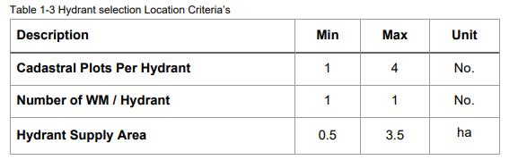

Based on the above assumptions was developed the distribution of the hydrants in project area.

The exact location of the hydrants remain open for discussions and decision is a compromise between the farmers and of the water management authority (Municipality of Divjaka) which can be saddled also during construction phase.

Regarding metering of the consumption, the consultant in the conceptual design presented 2 options. Based on these analyses the Option 1: Smart WM and prepaid System was selected for further development with detail design.

**APPENDIX A**

**PROPOSED REHABILITATION WORKS**

**B. BRIEF DESCRIPTION OF JANJAR - MURSI IRRIGATION SCHEME**

The possible main works to be carried out for the “Janjar-Mursi *Irrigation scheme*” are listed below:

1. Irrigation Rehabilitation Works:

• Replace open irrigation channels with pressurized pipes;

• Build a new pump station downstream Mursi reservoir;

**BRIEF DESCRIPTION OF JANJAR _ MURSI IRRIGATION SCHEME**

***1. Project area location and history***

Janjar & Mursi Irrigation scheme lies in the Municipality of Konispol covering an agricultural area of 5500ha. The municipality is in the southern edges of the country. Konispol is the southernmost town in Albania. It sits one kilometer away from the [Albanian-Greek border](https://en.wikipedia.org/wiki/Border_crossings_of_Albania). The main economic interests of Konispol are [agriculture](https://en.wikipedia.org/wiki/Agriculture) and [viticulture](https://en.wikipedia.org/wiki/Viticulture). The town is the seat of the southernmost administrative unit in [Albania](https://en.wikipedia.org/wiki/Albania), the Municipality of Konispol. It was formed during the 2015 local government reform by the merger of the former municipalities of Konispol, [Markat](https://en.wikipedia.org/wiki/Markat) and [Xarrë](https://en.wikipedia.org/wiki/Xarr%C3%AB). The total population is 8,245 (2011 census), in a total area of 221.88 km2.

The Janjar & Mursi irrigation scheme is composed of: i) Janjar Reservoir, including the dam and 43km of main irrigation canal of Janjar, Bufi Branch and Konispol; and ii) Mursi Reservoir, including the dam and 33km of main canals V1, V2 and their secondary canals and Mursi feeder canal 5km and its secondaries.

The dams of Janjar, Mursi and main canals of Janjar reservoir scheme were rehabilitated under the WRIP. The scope of this project is to modernize the network of irrigation channels of Mursi reservoir.

**2. MURSI IRRIGATION SCHEME**

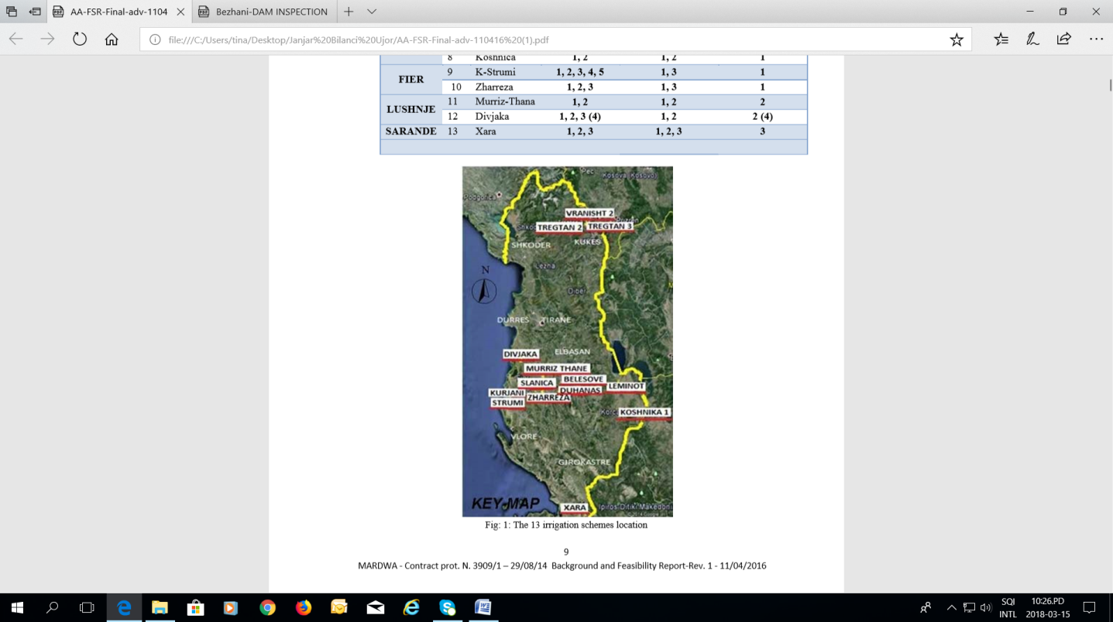Mursi is located in south of Saranda region and is part of the Mediterranean field Zone. Mean temperature is highly variable across this zone and declines moving from the south to the north and with increased elevation. The rainfall in winter is significant, and in the Saranda area during the period from October to April. This climate region is generally thought suitable for growing mandarins, oranges, olives, vineyards and fruit trees. The main water source for the lower part is Mursi Reservoir with a 4.5 Mm³ storage capacity.

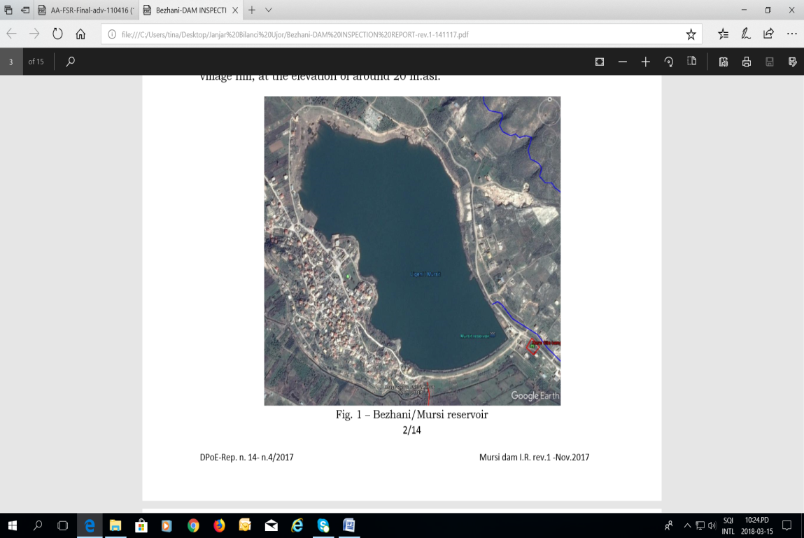**2.1 Mursi Reservoir**

Mursi/Bezhani reservoir, coordinates: 39°42’11.00”N and 20°05’16.78”E, is located in the littoral plain of Xarre on the East side of Mursi village hill, at the elevation of around 20m.asl. The reservoir is formed by an arch-shaped earth-fill embankment. The 5.6 km2 direct catchment area cannot fill the reservoir naturally and for this reason around 80% of its volume is filled diverting water from Pavla river all year long, by a rock fill diversion weir (Coordinates. N 39°42’27.14’’; E 20°07’26.46’’), conveying the river flows into the reservoir through a 4.7 km feeder channel bordering, on the river right side, the toe of the steep rocky hill.

**Irrigation canals of Mursi Reservoir**

The irrigation canal network of Mursi reservoir consists of two main irrigation canals V1, V2 and their secondary canals for a total length of 33km. The irrigation canal network is studied under the "Feasibility Study & Detailed Designs for I&D, Consultative Scheme, Training and Mobilization, carried out by the consultant JV Renardet, Beta Studio & Hydrowater" and detailed designs have been prepared. The Consultant shall review the detailed designs with respect to rehabilitation of the whole Janjar and Mursi irrigation scheme.

**Mursi Feeder Canal**

Since the Mursi reservoir cannot be filled up from its own watershed a feeder canal of 4.7km long has been originally designed. This canal takes water from Pavla river and flows to Mursi Reservoir. The feeder canal serves as the main water source for irrigating the 300ha of Manastir field which lies south/east of Mursi Reservoir as well.

**3.** **WATER SOURCE**

The main sources of the water for irrigation purposes in the project area are Janjar Reservoir (15 million cum) and Mursi reservoir (4 million cum). Janjar reservoir is mainly rain-fed whilst Mursi reservoir needs a supply canal taking water from Pavlla river to get filled. To provide pressure head for Mursi scheme a new pumping station will be built together with natural head provided by Janjar scheme through Bufi Branch.

**4**. **RELATED INFRASTRUCTURE TO THE PILOT AREA**

At the proposed project area, the following new & existing infrastructure shall be rehabilitated or built:

1. Primary canals of Mursi V1, V2, V3

2. Secondary canals V2/1-V2/2, V3/1-V3/5, V4-V4/4, V5, V6, V7-V7/1

3. Pump station